CMP6233 Modern Data Stores & Data Protection



Dr. Anuoluwapo Adewuyi

Week 3: CRUD in MongoDB

Week | Practical Lecture | Lab Exercises | Additional resources | Assessment Schedule
3 | CRUD – basic operations and schema design guidelines | CRUD practice | Mongo Atlas | Create Cluster and schema for assessment

3.1 Introduction
Last sessions you learnt how to create a collection (database) and to insert some documents. This session we are going to continue with learning about CRUD (Create, Read, Update and Delete). We have already used create and read in terms of creating a collection and documents, and we added additional attributes to a given document. We are now going to look at CRUD in more detail.
Recap:
You should now be able to:
- Create a collection
- Use a collection if it exists and create a new one if it does not exist
- Insert a document into a collection
- Read a document using find() and findOne()
We are now moving up to modifying a document.

3.2: Learning Plan:
Add these activities to your learning plan
- Complete this week’s lab exercises
- Now you have learnt how to create and insert data into a database, you can start your assessment:
- Create your Mongo database
- Start to think of what data you are going to load into your database by listing some of the documents you want to create and associated fields/attributes
- Create a (draft) Word document for your assessment report, so that you can add to it each week
- (Optional) Explore using Studio 3T https://studio3t.com/knowledge-base/articles/getting-started/ or MongoDB Compass
- Get Started with Atlas https://docs.atlas.mongodb.com/getting-started/

3.3: Lab Exercises:
Working with MongoDB-CRUD operation

The exercises given below covers all the basic (CRUD) operations in MongoDB.

- Connect to your Atlas (or local) database deployment with mongo shell (mongsh)
- Create database with name ‘faculty’ - use faculty;
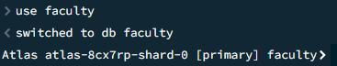
Exercise 1
Create a function student in JavaScript that stores the following documents in the database faculty. The collection name is score and students’ scores are randomly assigned.
Call the function to store the data of 100 students’ documents in the collection.
_id | Student_id | type | scores
Mongo ID object | 1 | exam | Math.random() * 100
Mongo ID object | 1 | homework | Math.random() * 100
Mongo ID object | 1 | quiz | Math.random() * 100
Mongo ID object | 2 | exam | Math.random() * 100
Mongo ID object | 2 | homework | Math.random() * 100
Mongo ID object | 2 | quiz | Math.random() * 100
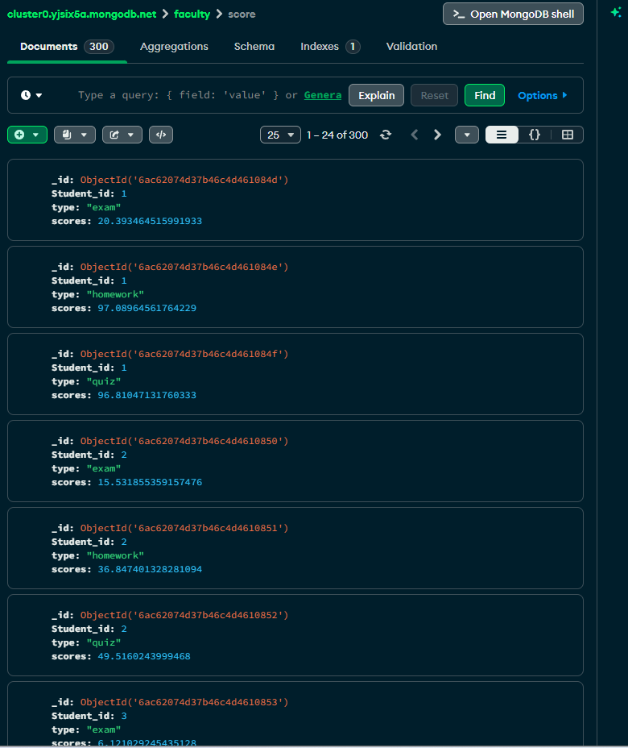
Query:

- Get the details for exam and quiz.
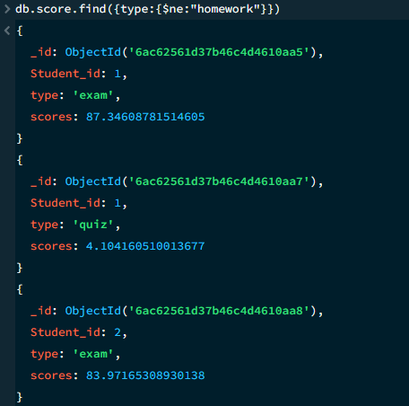
- Update all the quiz scores to zero for all the students.
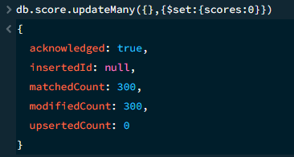
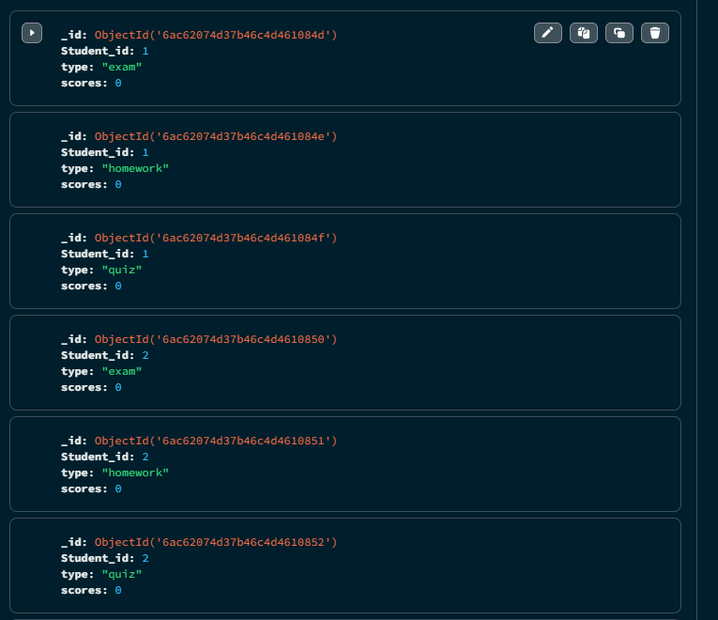
- Get the count of the students that got more than 50 scores in homework.
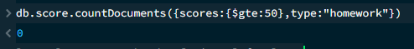

Exercise 2

Insert the following data into "staff" collection (Use insertMany())
db.staff.insertMany([
{ "name":"Ana", "age":35,"gender":"F","exp":10,subjects:["DS","C","OS"],"type":"Full Time","qualification":"M.Tech" },
{ "name":"Ina", "age":38,"gender":"F","exp":12,subjects:["JAVA","DBMS"],"type":"Full Time", "qualification":"Ph.D"},
{ "name":"Tom", "age":32,"gender":"M","exp":8,subjects:["C","CPP"],"type":"Part Time","qualification":"M.Tech" },
{ "name":"Kim", "age":40,"gender":"M","exp":9,subjects:["JAVA","DBMS","NETWORKING"],"type":"Full Time", "qualification":"Ph.D"},
{ "name":"Rajan", "age":35,"gender":"M","exp":7,subjects:["DS","C","OS"],"type":"Full Time","qualification":"M.Tech" },
{ "name":"Antonio", "age":38,"gender":"M","exp":10,subjects:["JAVA","DBMS","OS"],"type":"Part Time", "qualification":"Ph.D"},
{ "name":"Stiv", "age":32,"gender":"F","exp":8,subjects:["C","CPP","MATHS"],"type":"Part Time","qualification":"M.Tech" },
{ "name":"Nandi", "age":39,"gender":"M","exp":11,subjects:["JAVA","DBMS","NETWORKING"],"type":"Full Time", "qualification":"Ph.D"},
{ "name":"Natan", "age":35,"gender":"M","exp":9,subjects:["JAVA",".Net","NETWORKING"],"type":"Full Time", "qualification":"Ph.D"},
{ "name":"Liora", "age":40,"gender":"F","exp":13,subjects:["MATHS"],"type":"Full Time", "qualification":"Ph.D"}
]);
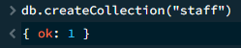
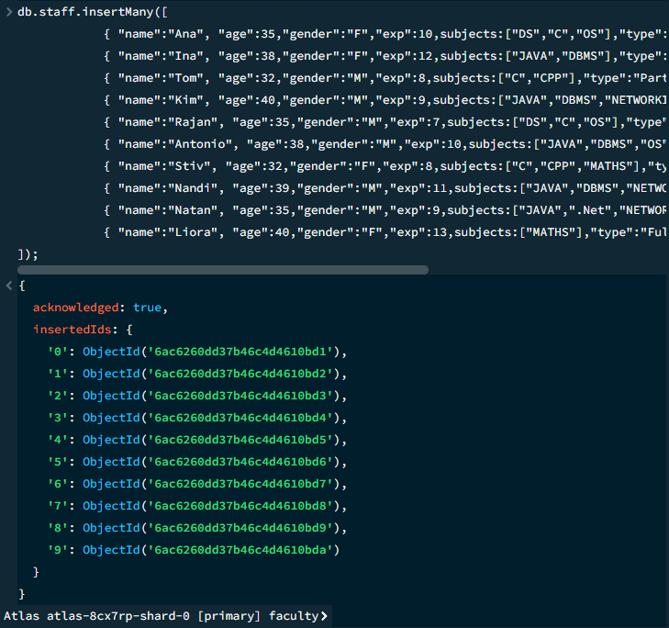
Write the following queries:

- Get the details of all the staff.
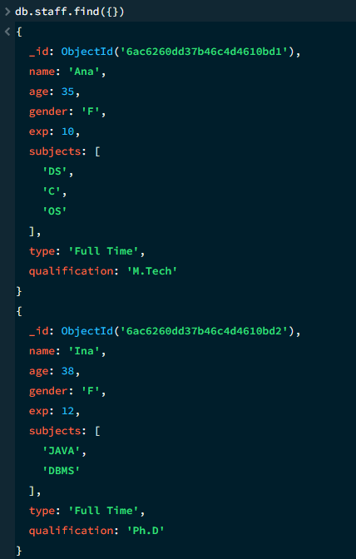
- Get the count of all staff members.
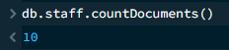
- Get all the staff members whose qualification is “M.Tech”.
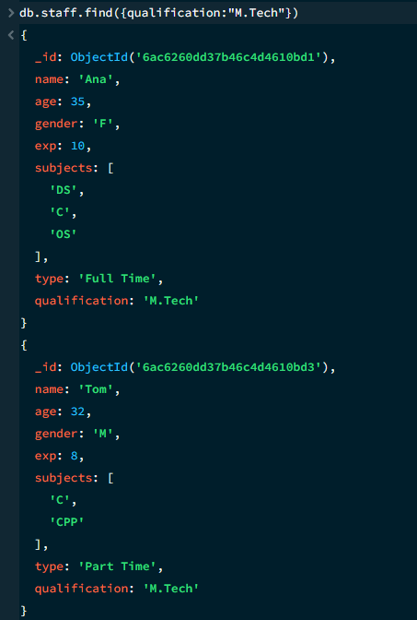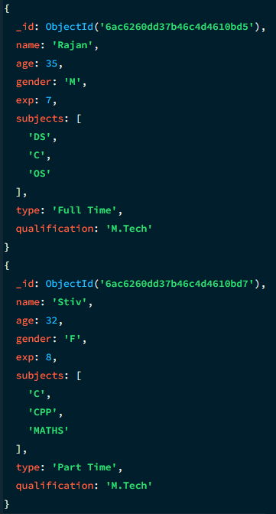
- Get all the staff members whose experience is between 8 to 12 years.
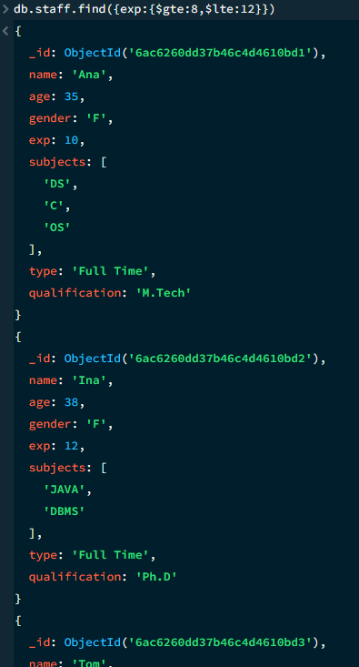
- Get all the staff members who teach “MATHS” or “JAVA”.
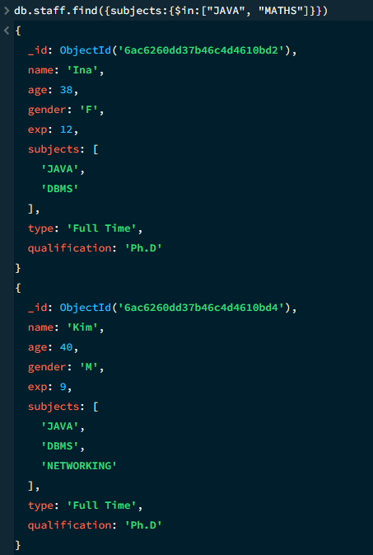
- Get all the staff members who teach “JAVA” and whose age is more than 20 years and qualification must be “Ph.D”.
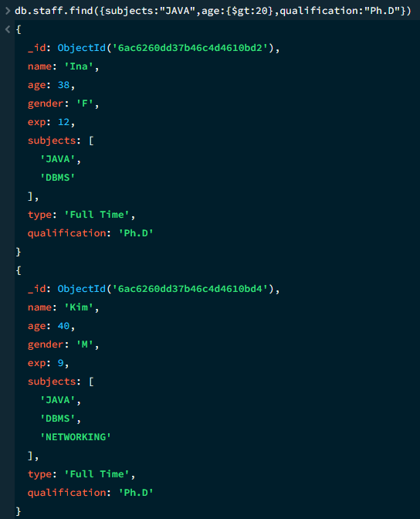
- Get all the staff members who are working part-time or who teach “JAVA”.
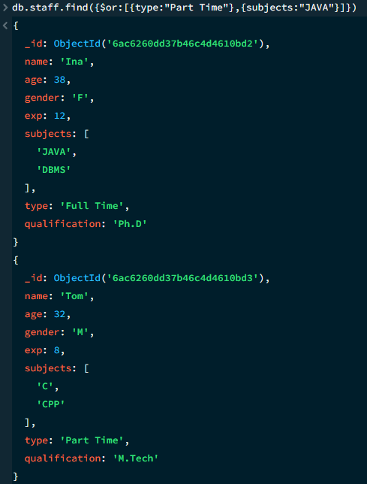
8. Add the following new staff members:
{ "name":"Susan", "age":36,"gender":"F","exp":15,subjects:["BIG DATA"," DATA MINING"],"type":"Full Time", "qualification":"Ph.D"}
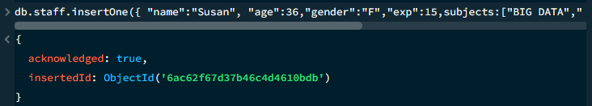
- Update the data of all staff members by incrementing their age and exp by two year.
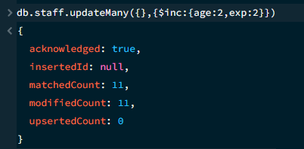
- Update the staff “Stiv” with the following data: update qualification to “Ph.D” and type to “Full Time”.
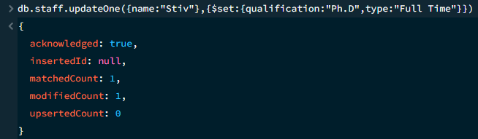
- Update all staff members who are teaching “MATHS” such that they should now also teach “PSK”.
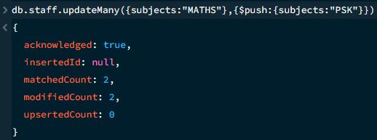
- Delete all staff members whose age is more than 55 years.
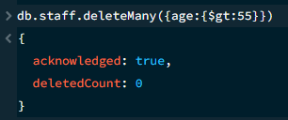
- Get only the name and qualification of all staff members.
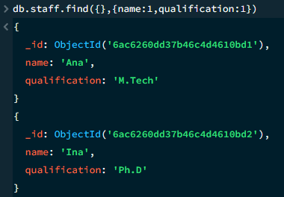
- Get the name, qualification and exp of all staff members and display the same in ascending order of exp.
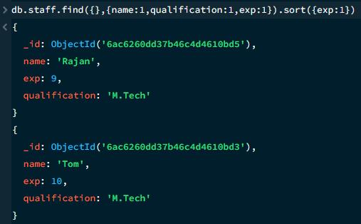
15. Sort the staff details by their age (descending order) and get the details of the first five staff members only.
